**Electricity Optimization Technology along with Internet of Things**

#### SUBMITTED BY

Siddhant Jain(2014BTECHCSE015)

Tanuj Kumar(2014BTECHCSE017)



**DEPARTMENT OF COMPUTER SCIENCE & ENGG.**

**INSTITUTE OF ENGINEERING & TECHNOLOGY**

**JK LAKSHMIPAT UNIVERSITY, JAIPUR**

**April, 2017**

**ABSTRACT**

Home devices, when remotely monitored and controlled via internet are an important constituent of the Internet Of Things. This device is a home automation concept which focuses on conservation of electricity. It is seen many times, actually most of the times that electronic appliances are kept working even when they are not in use. This device senses presence of people in the premises. After no presence is detected after 1 minute, the appliances in the premises are turned ‘off’ through this device. It involves the control and automation of lighting, heating, ventilation, air-conditioning, and security as well as home appliances such as washers/dryers, ovens or refrigerators/freezers. ELITE is the future of electricity saving.

**Table of Contents**

**CHAPTER No. TITLE Page No.**

**Abstract**

**List of Figures**

4.1 Use-Case

4.2 Context-Free

4.3 Entity Relation

4.4 Sequential

6.1 Landing Webpage

6.2 Motion Log Table

6.3 Start Time Table

6.4 Stop Time Table

6.5 Active Time Table

6.6 Final Circuit

6.7 Circuit View

6.8 Front View

**1 Introduction 3**

**2 Requirements for Proposed Work 4**

2.1 Software

2.1.1 Arduino IDE

2.1.2 XAMPP

2.2 Hardware

2.2.1 Arduino Uno

2.2.2 Passive Infrared Sensor

2.2.3 ESP8266(WiFi Module)

**3 Feasibility Study 6**

3.1 Technical Feasibility

3.2 Economic Feasibility

3.3 Operational Feasibility

**4 Data Structures 7**

4.1 Use-Case Diagram

4.2 Context-Free Diagram

4.3 Entity-Relationship Diagram

4.4 Sequential Diagram

**5 Code and test the project 14**

**6 Result & Glimpse 26**

**7 Conclusion & Future Scope 29**

**References**

Chapter1. Introduction:

Home automation or smart home (also known as domotics) is [building automation](https://en.wikipedia.org/wiki/Building_automation) for the home. It involves the control and automation of lighting, heating (such as [smart thermostats](https://en.wikipedia.org/wiki/Smart_thermostat)), ventilation, air conditioning ([HVAC](https://en.wikipedia.org/wiki/HVAC)), and security, as well as [home appliances](https://en.wikipedia.org/wiki/Home_appliance) such as washer/dryers, ovens or refrigerators/freezers. [Wi-Fi](https://en.wikipedia.org/wiki/Wi-Fi) is often used for remote monitoring and control. Home devices, when remotely monitored and controlled via the Internet, are an important constituent of the [Internet of Things](https://en.wikipedia.org/wiki/Internet_of_Things). Modern systems generally consist of switches and sensors connected to a central hub sometimes called a "gateway" from which the system is controlled with a [user interface](https://en.wikipedia.org/wiki/User_interface) that is interacted either with a wall-mounted terminal, mobile phone software, [tablet computer](https://en.wikipedia.org/wiki/Tablet_computer) or a web interface, often but not always via Internet cloud services.

In today’s fast era, it is totally required that we do look onto our energy consumption. It is predicted by our scientists that if we keep on spending our resources with the same audacity, we would soon have the scarcity of our energy resources. It is an alarming situation for us. Therefore, it is recommended that we make a move towards saving our resources from wastage. Electricity is the most specific of all the resources.

This is the time when ELITE comes into picture. ELITE, an Electricity Optimization Technology along with Internet of things. This device is a home automation concept which focuses on conservation of electricity from wastage. It is generally seen that home appliances keeps on working even when no one is using them. Therefore, ELITE is the one which saves a lot of bucks and prevents people wasting electricity.

This device can be installed on the door of a room. It works with PIR sensing technology. It senses the presence of a person in the room. After the person enters the room, he/she switches ‘on’ the appliances. It is seen many times, actually almost all times that those appliances are kept working even after everyone leaves the room. This device senses the absence of the people and after 1 minute of no presence, the appliances of the room are turned ‘off’ automatically through ELITE. And not only that, the person who installs this can keep the record of the usage of electricity remotely on a server.

**Chapter 2: Requirements for Proposed Work**

**2.1 Software:**

**2.1.1 Arduino IDE:**

The open-source Arduino Software (IDE) makes it easy to write code and upload it to the board. It runs on Windows, Mac OS X, and Linux. The environment is written in Java and based on Processing and other open-source software.

**2.1.2 XAMPP:**

XAMPP is a [free and open source](https://en.wikipedia.org/wiki/Free_software) [cross-platform](https://en.wikipedia.org/wiki/Cross-platform) [web server](https://en.wikipedia.org/wiki/Web_server) [solution stack](https://en.wikipedia.org/wiki/Solution_stack) package developed by Apache Friends, consisting mainly of the [Apache HTTP Server](https://en.wikipedia.org/wiki/Apache_HTTP_Server), [MariaDB](https://en.wikipedia.org/wiki/MariaDB" \o "MariaDB) [database](https://en.wikipedia.org/wiki/Database), and [interpreters](https://en.wikipedia.org/wiki/Interpreter_(computing)) for scripts written in the [PHP](https://en.wikipedia.org/wiki/PHP) and [Perl](https://en.wikipedia.org/wiki/Perl) [programming languages](https://en.wikipedia.org/wiki/Programming_language). XAMPP stands for Cross-Platform (X), Apache (A), MariaDB (M), PHP (P) and Perl (P). It is a simple, lightweight Apache distribution that makes it extremely easy for developers to create a local web server for testing and deployment purposes. Everything needed to set up a web server – server application (Apache), database (MariaDB), and scripting language (PHP) – is included in an extractable file. XAMPP is also cross-platform, which means it works equally well on Linux, Mac and Windows. Since most actual web server deployments use the same components as XAMPP, it makes transitioning from a local test server to a live server extremely easy as well.

**2.2 Hardware:**

**2.2.1 Arduino Uno:**

Arduino is an open source, computer hardware and software company, project, and user community that designs and manufactures [microcontroller](https://en.wikipedia.org/wiki/Microcontroller) kits for building digital devices and interactive objects that can sense and control objects in the physical world. The project's products are distributed as [open-source hardware](https://en.wikipedia.org/wiki/Open-source_hardware) and [software](https://en.wikipedia.org/wiki/Open-source_software), which are licensed under the [GNU Lesser General Public License](https://en.wikipedia.org/wiki/GNU_Lesser_General_Public_License) (LGPL) or the [GNU General Public License](https://en.wikipedia.org/wiki/GNU_General_Public_License) (GPL), permitting the manufacture of Arduino boards and software distribution by anyone. Arduino boards are available commercially in preassembled form, or as [do-it-yourself](https://en.wikipedia.org/wiki/Do-it-yourself) kits.Arduino board designs use a variety of microprocessors and controllers. The boards are equipped with sets of digital and analog [input/output](https://en.wikipedia.org/wiki/Input/output) (I/O) pins that may be interfaced to various expansion boards (*shields*) and other circuits. The boards feature serial communications interfaces, including [Universal Serial Bus](https://en.wikipedia.org/wiki/Universal_Serial_Bus) (USB) on some models, which are also used for loading programs from personal computers. The microcontrollers are typically programmed using a dialect of features from the programming languages [C](https://en.wikipedia.org/wiki/C_(programming_language)) and [C++](https://en.wikipedia.org/wiki/C%2B%2B). In addition to using traditional compiler toolchains, the Arduino project provides an [integrated development environment](https://en.wikipedia.org/wiki/Integrated_development_environment) (IDE) based on the [Processing](https://en.wikipedia.org/wiki/Processing_(programming_language)) language project.

**2.2.2 Passive Infrared Sensor (PIR):**

A passive infrared sensor (PIR sensor) is an electronic [sensor](https://en.wikipedia.org/wiki/Sensor) that measures [infrared](https://en.wikipedia.org/wiki/Infrared) (IR) light radiating from objects in its field of view. They are most often used in [PIR-based motion detectors](https://en.wikipedia.org/wiki/Passive_infrared_sensor#MOTION). A PIR-based [motion detector](https://en.wikipedia.org/wiki/Motion_detector) is used to sense movement of people, animals, or other objects. They are commonly used in [burglar alarms](https://en.wikipedia.org/wiki/Burglar_alarm) and automatically-activated [lighting](https://en.wikipedia.org/wiki/Lighting) systems. They are commonly called simply "PIR", or sometimes "PID", for "passive infrared detector".

**2.2.3ESP8266(WiFi Module):**

The ESP8266 is a low-cost [Wi-Fi](https://en.wikipedia.org/wiki/Wi-Fi) chip with full TCP/IP stack and [MCU (Micro Controller Unit)](https://en.wikipedia.org/wiki/Microcontroller) capability produced by Shanghai-based Chinese manufacturer, [Espressif Systems](https://en.wikipedia.org/w/index.php?title=Espressif_Systems&action=edit&redlink=1" \o "Espressif Systems (page does not exist)). The chip first came to the attention of western [makers](https://en.wikipedia.org/wiki/Maker_culture) in August 2014 with the ESP-01 module, made by a third-party manufacturer, AI-Thinker. This small module allows microcontrollers to connect to a Wi-Fi network and make simple TCP/IP connections using [Hayes](https://en.wikipedia.org/wiki/Hayes_command_set)-style commands. However, at the time there was almost no English-language documentation on the chip and the commands it accepted. The very low price and the fact that there were very few external components on the module which suggests that it could eventually be very inexpensive in volume, attracted many hackers to explore the module, chip, and the software on it, as well as to translate the Chinese documentation.

**Chapter 3: Feasibility Study**

**3.1 Technical Feasibility:**

This project provides a deep feasibility in the field of power saving and upgrading towards the future. Today, the world is going towards a greener era. This device can be easily clubbed with the idea of “Eco Buildings” (currently implemented in Korea), as it can provide a means to monitor the usage of electricity in a particular premises. As well as when upgraded it can even trigger fire and intruder alarm if needed and if upgraded. This means the user buys one device and gets the benefits of all the three devices. And not just that this device can be a remote switch which can be used to turn ‘on’ or ‘off’ if the user forgets or wants to use the appliances when not at home. Hence, there is a huge technical feasibility in the area of this project. The technology that is used in this device is currently available but is not in use. This device uses Raspberry Pi, PLC circuits and motion sensors that are very efficient in implementing such type of ideas.

**3.2 Economic Feasibility:**

This project shows a huge difference in the expenses that are spent on the electricity all over the world. As this device shows the consumption of electricity in different areas where the device is plotted as well as by different appliances. As there is a lot of useless consumption of electricity along different areas. People do forget to turn ‘off’ the appliances many times when they get busy in some other works. Here comes the role of this device, it turns ‘off’ the appliances after a particular time interval if no movement is detected. Hence, this device saves many bucks that are uselessly spent on the useless consumption of electricity and it can even save near about 30-40% of the total consumption of electricity.

**3.3 Operational Feasibility:**

In this project, we do require that the device mentioned, should be efficient enough to do the task of turning ‘off’ the appliances when not in use after a certain time. The technology used in this device can be programmed to do such task and give a status report as well to the concerned person (administrator, to whom the system is operable).

**Chapter 4.** **Data Structures:**

4.1 Use-Case Diagram:

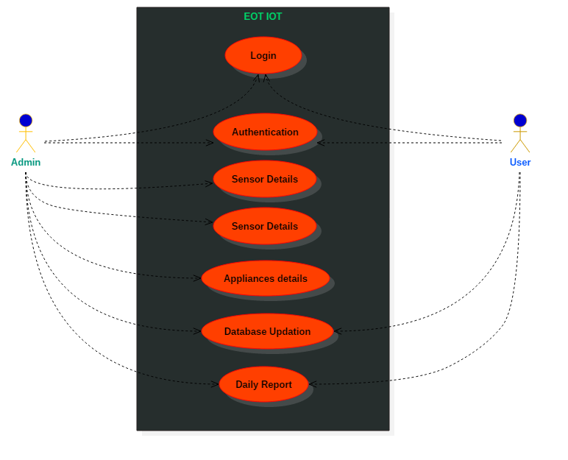

Fig 4.1: Use-Case Diagram

**4.2 Context-Free Diagram:**

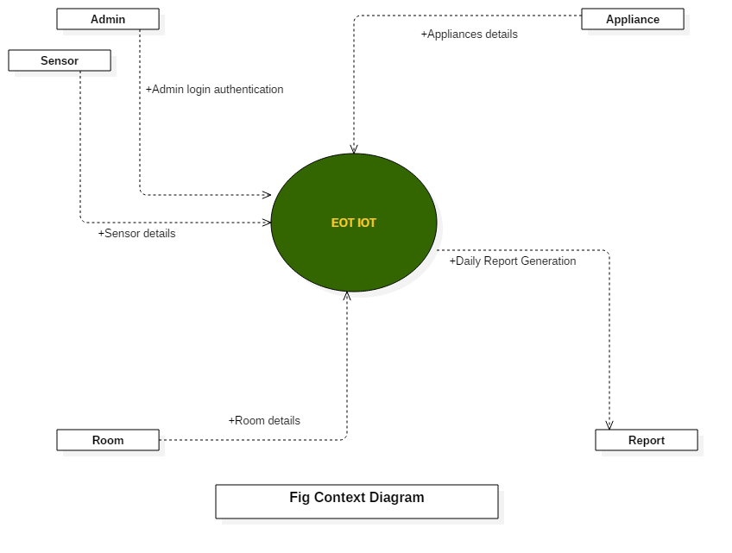

Fig 4.2: Context-Free Diagram

4.3 Entity-Relationship Diagram:

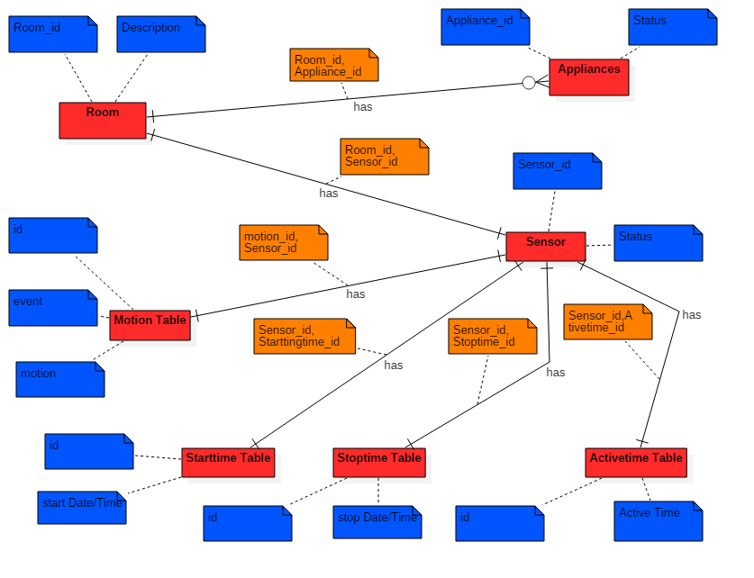

Fig 4.3: E-R Diagram

4.4 Sequential Diagram:

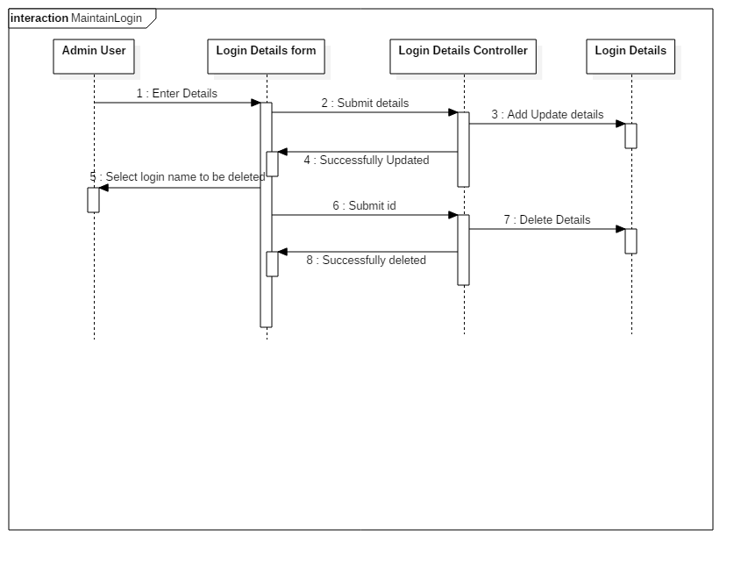

Fig 4.4.1: User & Admin Login

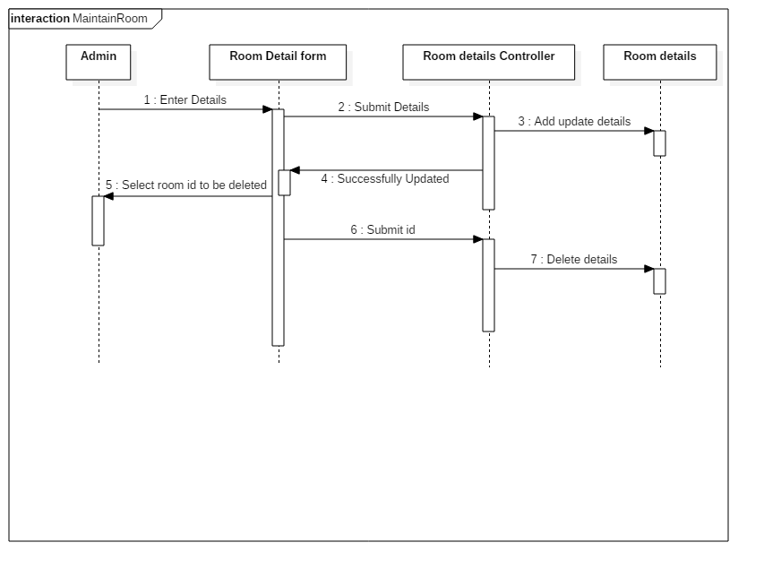

Fig 4.4.2: Maintain Room

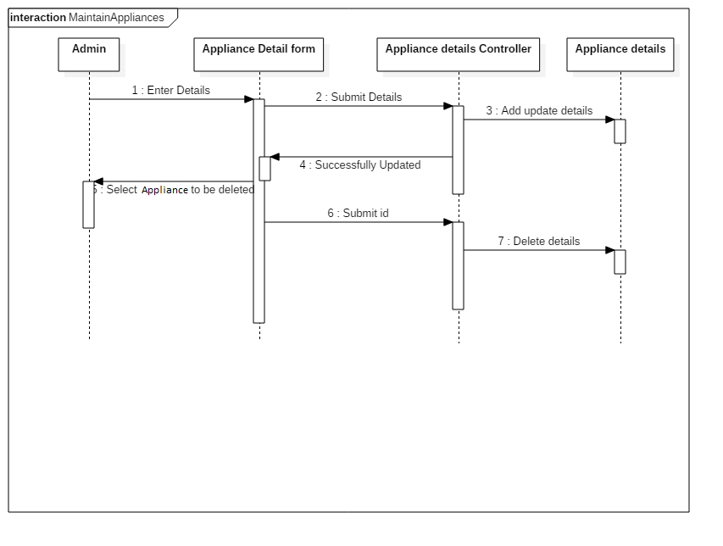

Fig 4.4.3: Maintain Appliances

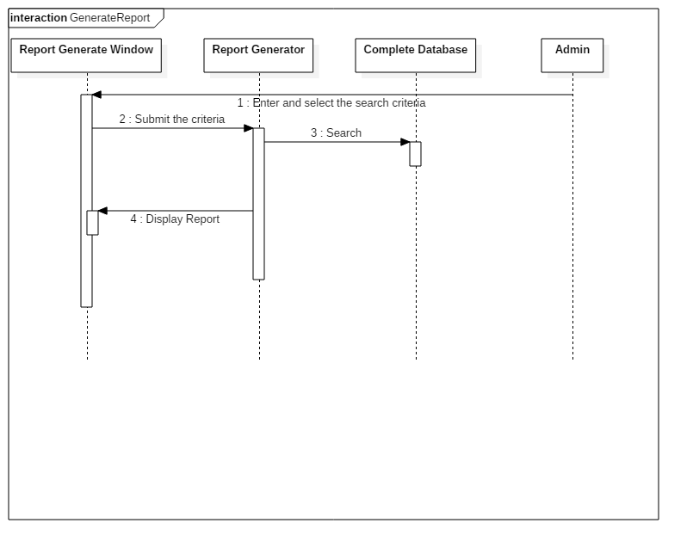

Fig 4.4.4: Generate Reports

Chapter 5. Code and test the project:

//Data Entry

<?php

// Connect to MySQL

include("dbconnect.php");

$sensor = $_GET['motionornot'];

$SQL = "INSERT INTO motion (motion) VALUES ($sensor)";

$con->query($SQL);

if($sensor == "1"){

$SQL = "INSERT INTO motion (motion) VALUES ($sensor);";

$SQL .= "INSERT INTO starttime (motion) VALUES ($sensor);";

mysqli_multi_query($con,$SQL);

}

else{

$SQL = "INSERT INTO motion (motion) VALUES ($sensor);";

$SQL .= "INSERT INTO stoptime (motion) VALUES ($sensor);";

$SQL .= "INSERT INTO activetime (activeTime) SELECT TIMEDIFF((SELECT stopTime from stoptime where id=(SELECT max(id) from stoptime)),

(SELECT startTime from starttime where id=(SELECT max(id) from starttime)))";

mysqli_multi_query($con,$SQL);

}

header("Location: data_review.php");

?>

//Data Review

<?php

// Start MySQL connection

include('dbconnect.php');

?>

<html>

<head>

<style>

div.container {

width: 100%; margin:auto; background: #91c7ff;

background: -webkit-gradient(linear, left top, left bottom, from(#eee), to(#ccc));

background: -moz-linear-gradient(top, #eee, #ccc);

-webkit-border-radius: 16px;

-moz-border-radius: 16px;

}

header, footer {

padding: 1em;

color: white;

background-color: black;

clear: left;

text-align: center;

}

#main-content { padding: 1px;}

nav {

float: left;

max-width: 160px;

margin: 0;

padding: 1em;

}

nav ul {

list-style-type: none;

border-right: 1px solid black;

padding: 0;

}

nav ul a {

text-decoration: none;

}

article {

margin-left: 170px;

padding: 1em;

overflow: auto;

}

a:hover {

color: black;

background: white;

}

.button {

background-color: black;

border: none;

width: 55%;

color: white;

padding: 15px 32px;

text-align: center;

text-decoration: none;

display: inline-block;

font-size: 16px;

margin: 4px 2px;

cursor: pointer;

}

.table_titles, .table_cells_odd, .table_cells_even {

padding-right: 20px;

padding-left: 20px;

color: #000;

}

.table_titles {

color: #FFF;

background-color: black;

}

.table_cells_odd {

background-color: #CCC;

}

.table_cells_even {

background-color: #FAFAFA;

}

table {

border: 2px solid #333;

width: auto;

}

</style>

<script type="text/javascript" src="http://ajax.googleapis.com/ajax/libs/jquery/1.7.1/jquery.min.js"></script>

</head>

<body>

<div class="container">

<div id="page-wrap">

<header>

<h1>EOT-IOT: HOME-AUTOMATION</h1>

</header>

<nav>

<ul>

<li><a href="#" class="button link" data-link="first">Motion Log Table</a></li>

<li><a href="#" class="button link" data-link="second">Active Time Table</a></li>

<li><a href="#" class="button link" data-link="third">Starting Time Table</a></li>

<li><a href="#" class="button link" data-link="fourth">Stopping Time Table</a></li>

</ul>

</nav>

<section id="main-content">

<!-- About the Project -->

<div class="textWord_about_project">

<h1><marquee width="80%" behavior="alternate"><font size="100" style="oblique" >WELCOME</marquee></font></h1>

</div>

<!-- Motion Log Start -->

<div class="textWord_about" data-link="first">

<h1 style align="center">MOTION LOG</h1>

<table align="center" border="0" cellspacing="0" cellpadding="4">

<tr>

<td class="table_titles">ID</td>

<td class="table_titles">EVENT</td>

<td class="table_titles">MOTION</td>

</tr>

<?php

// Retrieve all records and display them

$SQL = "SELECT * from motion";

$result = mysqli_query($con,$SQL);

// Used for row color toggle

$oddrow = true;

// process every record

while( $row = mysqli_fetch_array($result) )

{

if ($oddrow)

{

$css_class=' class="table_cells_odd"';

}

else

{

$css_class=' class="table_cells_even"';

}

$oddrow = !$oddrow;

echo '<tr>';

echo ' <td'.$css_class.'>'.$row["id"].'</td>';

echo ' <td'.$css_class.'>'.$row["event"].'</td>';

echo ' <td'.$css_class.'>'.$row["motion"].'</td>';

echo '</tr>';

}

?>

</table>

</div>

<!-- Active Time Log -->

<div class="textWord_about" data-link="second">

<h1 style align="center">ACTIVE TIME LOG</h1>

<table align="center" border="0" cellspacing="0" cellpadding="4">

<tr>

<td class="table_titles">ID</td>

<td class="table_titles">START DATE-TIME</td>

<td class="table_titles">STOP DATE-TIME</td>

<td class="table_titles">ACTIVE TIME</td>

</tr>

<?php

// Retrieve all records and display them

$SQL = "SELECT starttime.id, starttime.startTime, stoptime.stopTime, activetime.activeTime from starttime INNER JOIN stoptime INNER JOIN activetime ON starttime.id=stoptime.id=activetime.id";

$result = mysqli_query($con,$SQL);

// Used for row color toggle

$oddrow = true;

// process every record

while( $row = mysqli_fetch_array($result) )

{

if ($oddrow)

{

$css_class=' class="table_cells_odd"';

}

else

{

$css_class=' class="table_cells_even"';

}

$oddrow = !$oddrow;

echo '<tr>';

echo ' <td'.$css_class.'>'.$row["id"].'</td>';

echo ' <td'.$css_class.'>'.$row["startTime"].'</td>';

echo ' <td'.$css_class.'>'.$row["stopTime"].'</td>';

echo ' <td'.$css_class.'>'.$row["activeTime"].'</td>';

echo '</tr>';

}

?>

</table>

</div>

<!-- Start Time Log -->

<div class="textWord_about" data-link="third">

<h1 style align="center">START TIME LOG</h1>

<table align="center" border="0" cellspacing="0" cellpadding="4">

<tr>

<td class="table_titles">ID</td>

<td class="table_titles">START DATE-TIME</td>

<td class="table_titles">MOTION</td>

</tr>

<?php

// Retrieve all records and display them

$SQL = "SELECT * from starttime";

$result = mysqli_query($con,$SQL);

// Used for row color toggle

$oddrow = true;

// process every record

while( $row = mysqli_fetch_array($result) )

{

if ($oddrow)

{

$css_class=' class="table_cells_odd"';

}

else

{

$css_class=' class="table_cells_even"';

}

$oddrow = !$oddrow;

echo '<tr>';

echo ' <td'.$css_class.'>'.$row["id"].'</td>';

echo ' <td'.$css_class.'>'.$row["startTime"].'</td>';

echo ' <td'.$css_class.'>'.$row["motion"].'</td>';

echo '</tr>';

}

?>

</table>

</div>

<!-- Stop Time Log -->

<div class="textWord_about" data-link="fourth">

<h1 style align="center">STOP TIME LOG</h1>

<table align="center" border="0" cellspacing="0" cellpadding="4">

<tr>

<td class="table_titles">ID</td>

<td class="table_titles">STOP DATE-TIME</td>

<td class="table_titles">MOTION</td>

</tr>

<?php

// Retrieve all records and display them

$SQL = "SELECT * from stoptime";

$result = mysqli_query($con,$SQL);

// Used for row color toggle

$oddrow = true;

// process every record

while( $row = mysqli_fetch_array($result) )

{

if ($oddrow)

{

$css_class=' class="table_cells_odd"';

}

else

{

$css_class=' class="table_cells_even"';

}

$oddrow = !$oddrow;

echo '<tr>';

echo ' <td'.$css_class.'>'.$row["id"].'</td>';

echo ' <td'.$css_class.'>'.$row["stopTime"].'</td>';

echo ' <td'.$css_class.'>'.$row["motion"].'</td>';

echo '</tr>';

}

?>

</table>

</div>

</section>

<footer>Copyright &copy; 2017 Tanuj Kumar</footer>

</div>

</div>

<script type="text/javascript">

$('.textWord_about').hide();

$('.link').click(function() {

$('.textWord_about').hide();

$('.textWord_about_project').hide();

$('.textWord_about[data-link=' + $(this).data('link') + ']').fadeIn({

width: '200px'

}, 300);

});

</script>

</body>

</html>

//Connection with MySQL Database

//Connection with MySQL Database

<?php

$MyUsername = "root"; // mysql username

$MyPassword = ""; // mysql password

$MyHostname = "localhost"; // Your Host

$Database = "arduinodb"; // Name of your database

$con = mysqli_connect($MyHostname , $MyUsername, $MyPassword, $Database);

if (!$con) {

die("Connection failed: " . mysqli_connect_error());

}

?>

**Chapter 6. Result & Glimpse:**

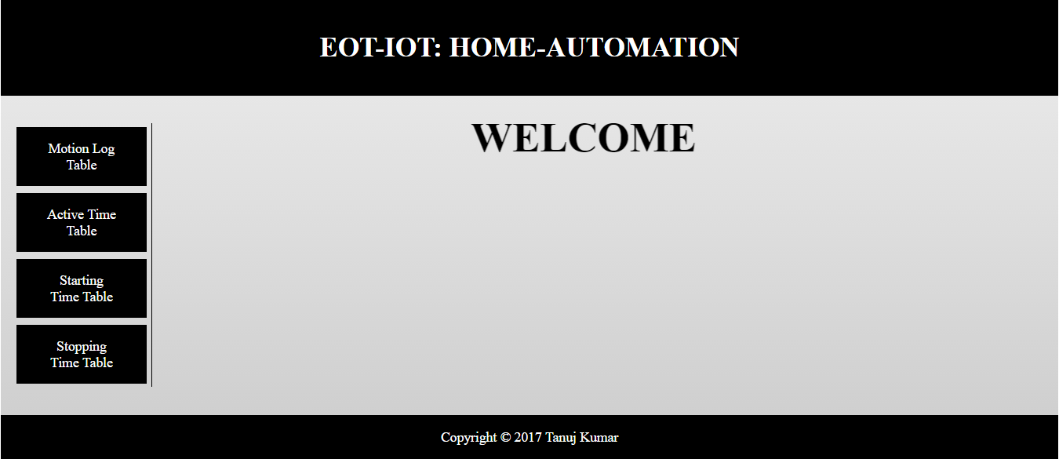

**Fig 6.1: Landing Webpage**

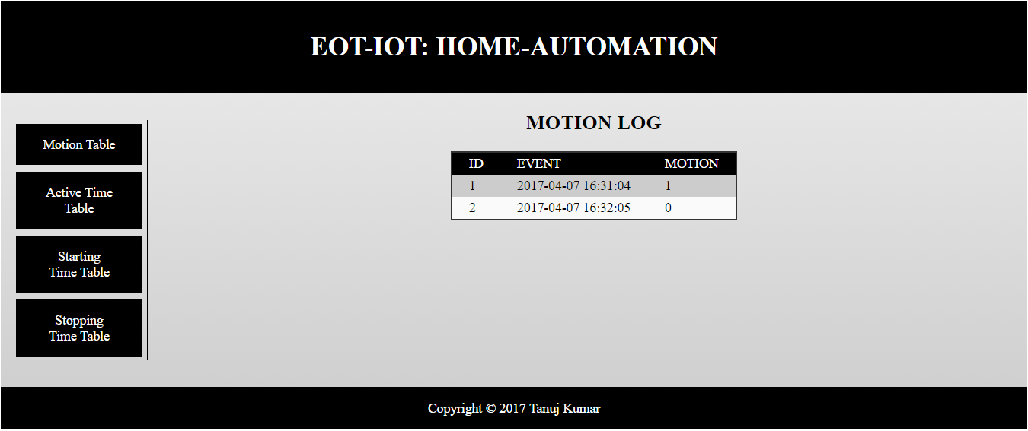

Fig6.2: Motion Log Table

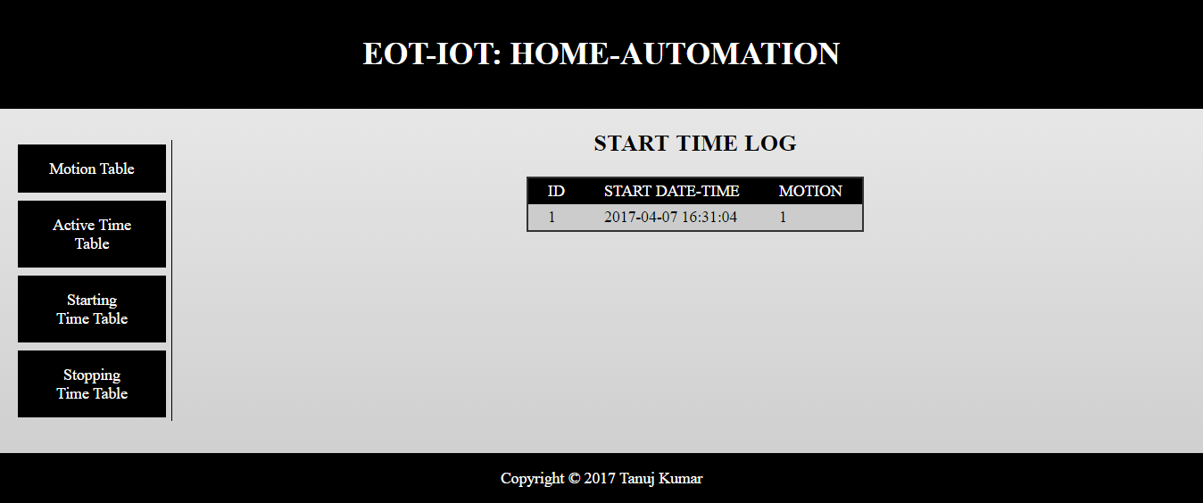

Fig6.3: Start Time Table

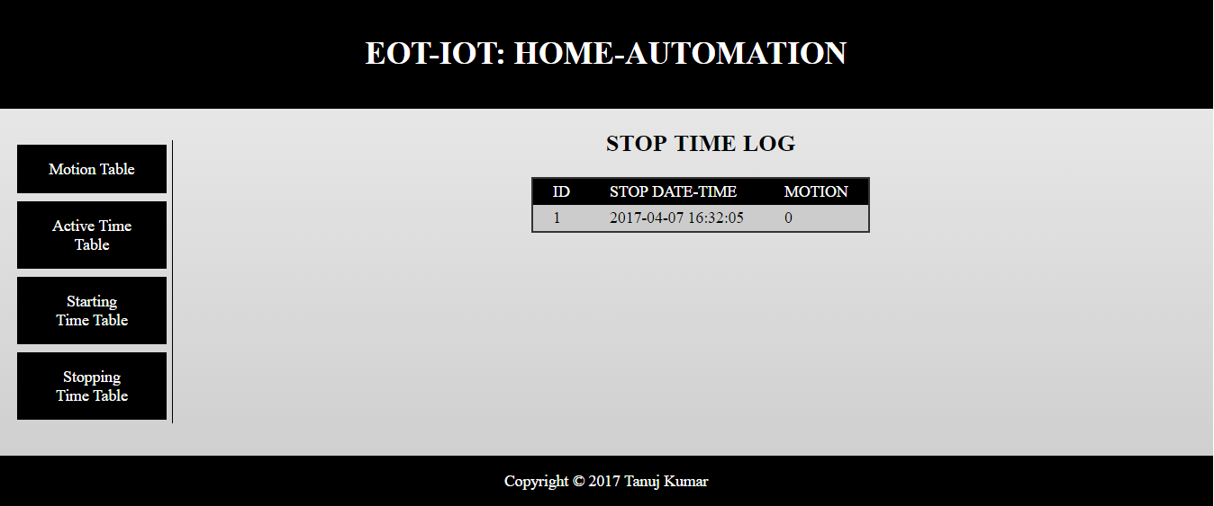

Fig6.4: Stop Time Table

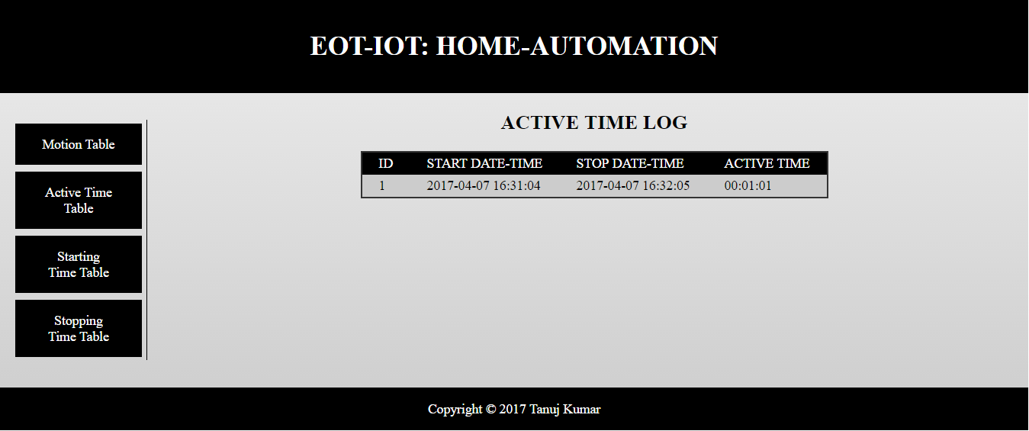

Fig6.5: Active Time Table

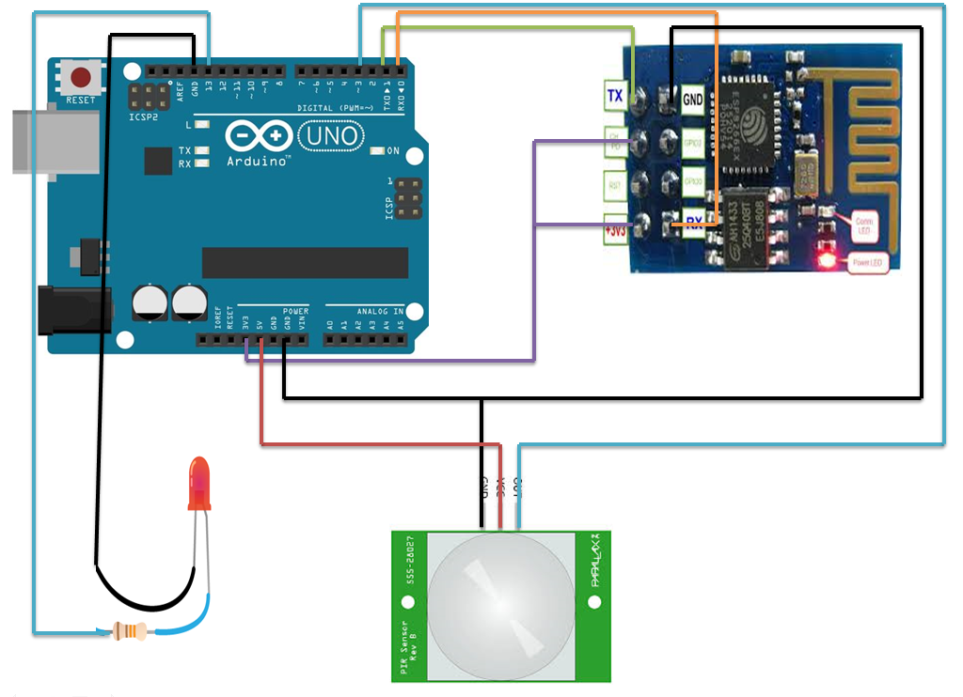

Fig6.6: Final Circuit

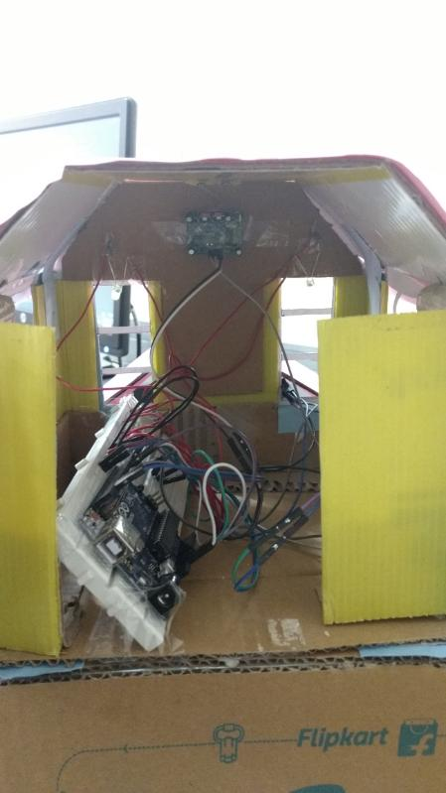

**Fig6.7: Circuit View**

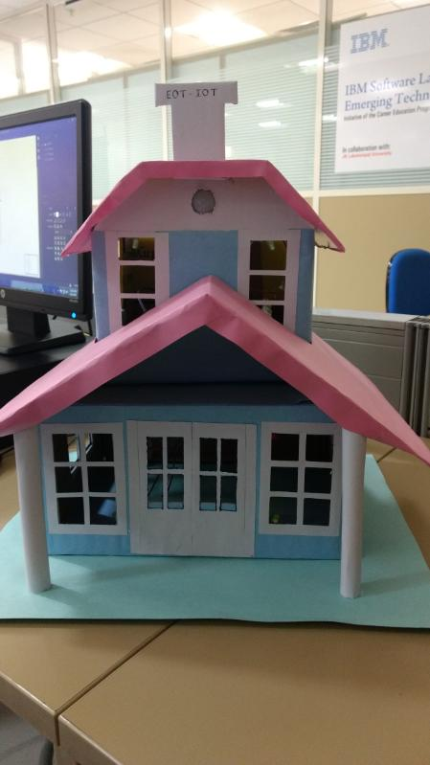

Fig6.8: Front View

Chapter 7. Conclusion & Future scope:

Automation is, unsurprisingly, one of the two main characteristics of home automation. Automation refers to the ability to program and schedule events for the devices on the network. The programming may include time-related commands, such as having your lights turn on or off at specific times each day. It can also include non-scheduled events, such as turning on all the lights in your home when your security system alarm is triggered.

Once you start to understand the possibilities of home automation scheduling, you can come up with any number of useful and creative solutions to make your life better. Is that west-facing window letting in too much light? Plug your motorized blinds into a "smart" outlet and program it to close at noon each day. Do you have someone come by at the same time each day to walk the dog? Program your home automation system to unlock the front door for them, and lock it up again when they're done.

A few years ago, only small startups and leading-edge visionaries, like Neil Gershenfeld, director of MIT's Center for Bits and Atoms, and Nicholas Negroponte, author of *Being Digital*, were promoting the idea of smart homes. But today, mainstream homebuilders, local home-networking integrators and even home-furnishings suppliers, such as Sears, are offering goods and services to smarten up your living space.

References:

* [www.w3schools.com](http://www.w3schools.com)
* www.arduino.cc
* [www.codepen.com](http://www.codepen.com)
* <http://www.technewsworld.com>
* [www.thasmai.net](http://www.thasmai.net)
* [www.javaturorials.com](http://www.javaturorials.com)